Nama : Raihan Rahmanda Junianto

NIM : 222112303

Kelas : 2KS4

**Praktikum Pertemuan 9 Pemrograman Berbasis Web**

1. **File php09A.php**

Source code:

Output:

1. **File php09B.php**

Source code:

Output:

1. **File php09C.php**

Source code:

Output:

1. **File php09D.php**

Source code:

Output:

1. **File php09E.php**

Source code:

Output:

1. **File php09E_action.php**

Source code:

Output:

1. **File php09F.php**

Source code:

Output:

1. **File php09G.php**

Source code:

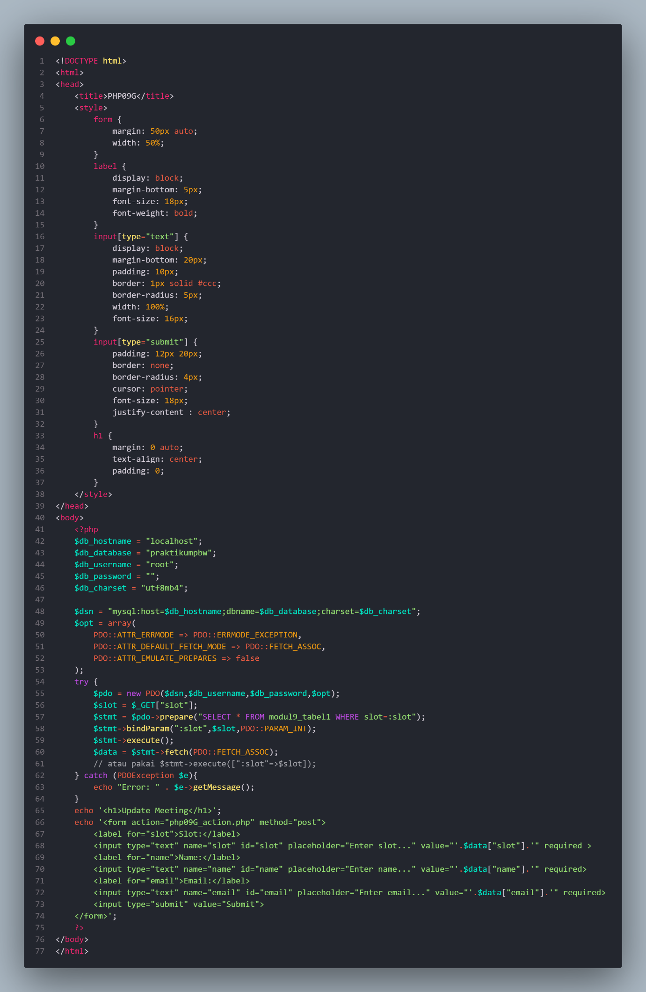

Output:

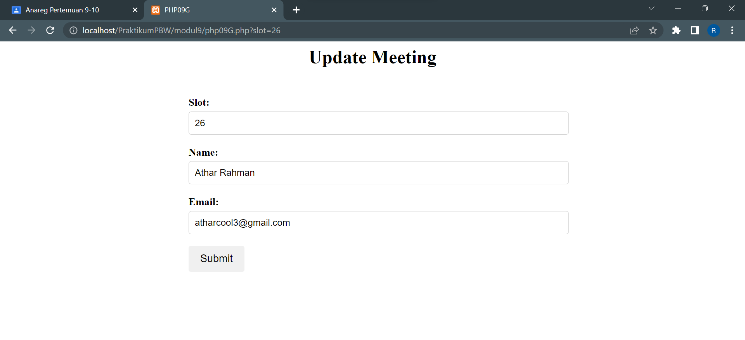

1. **File php09G_action.php**

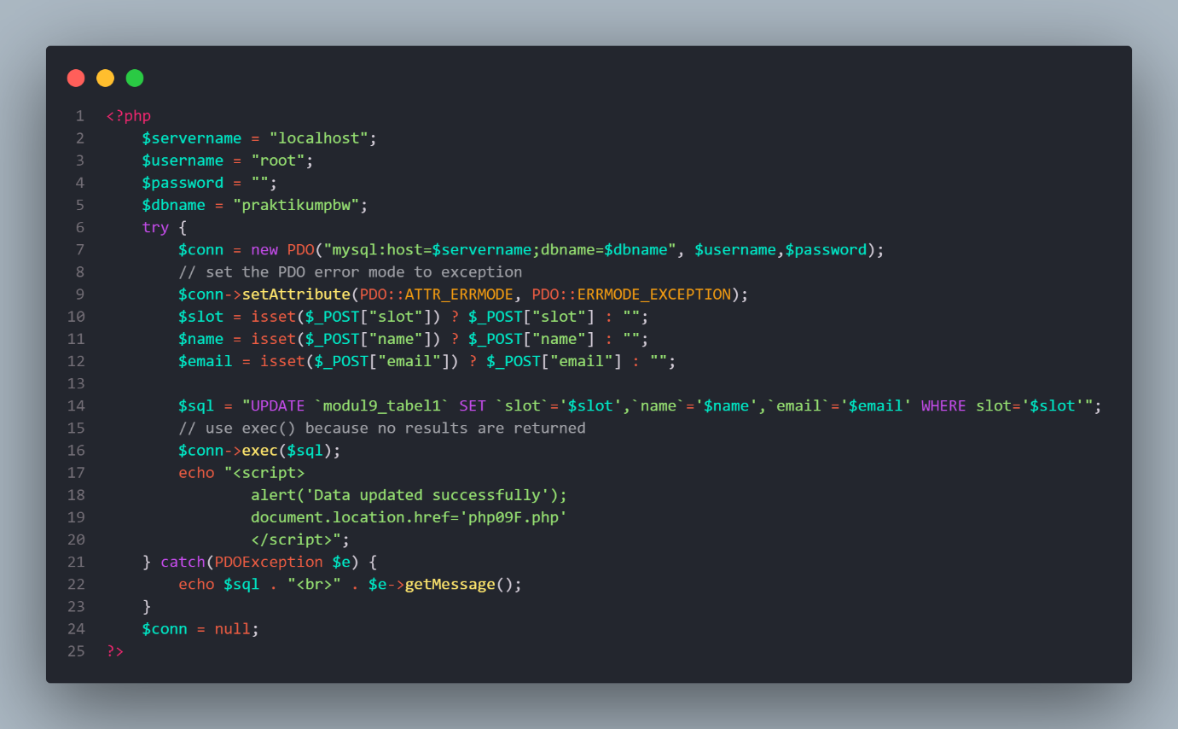

Output:

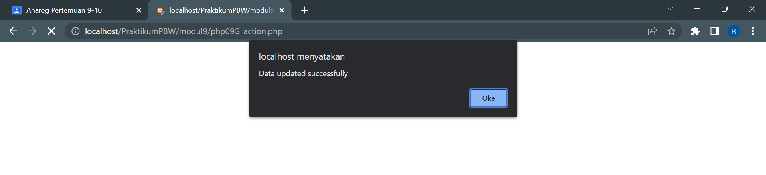

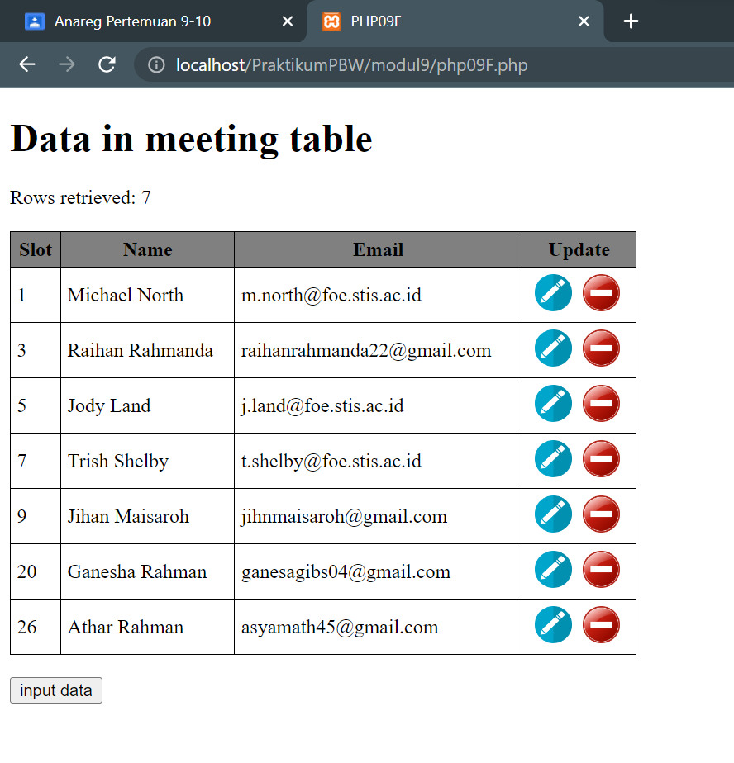

1. **File php09H.php**

Source code:

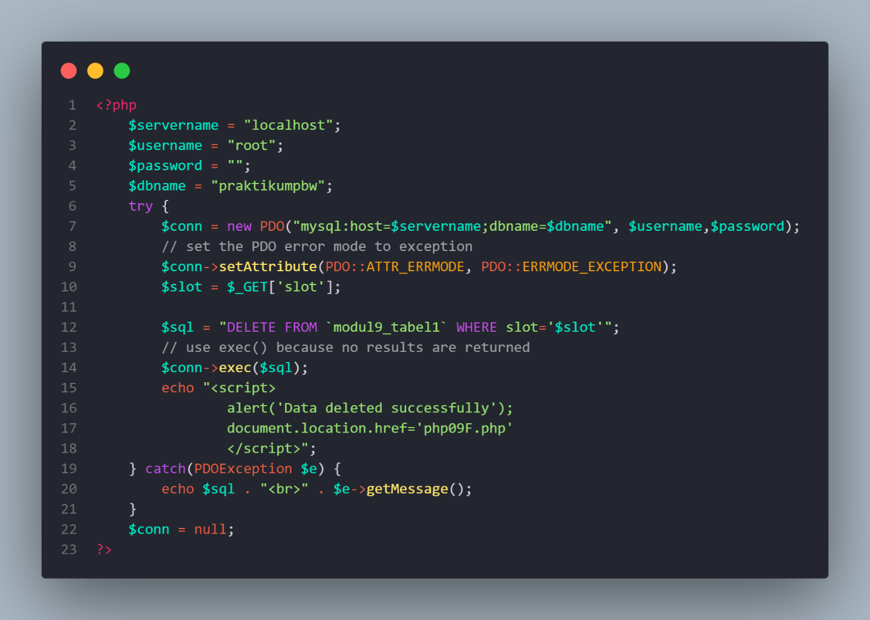

Output:

